**RENTED VEHICLE MANAGEMENT SYSTEM**

**1) Alter**

Original DB of Customer:

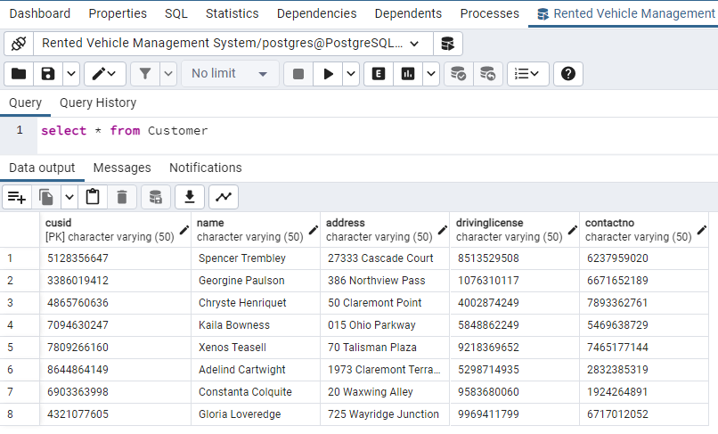

Altered Table for Adding a Column:

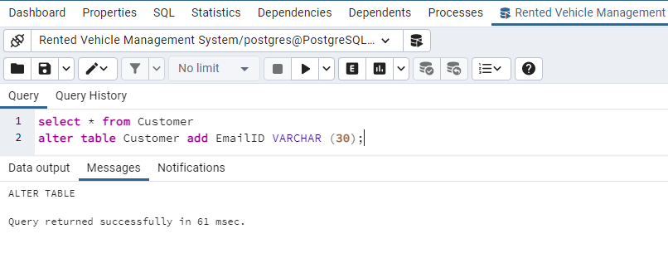

Output:

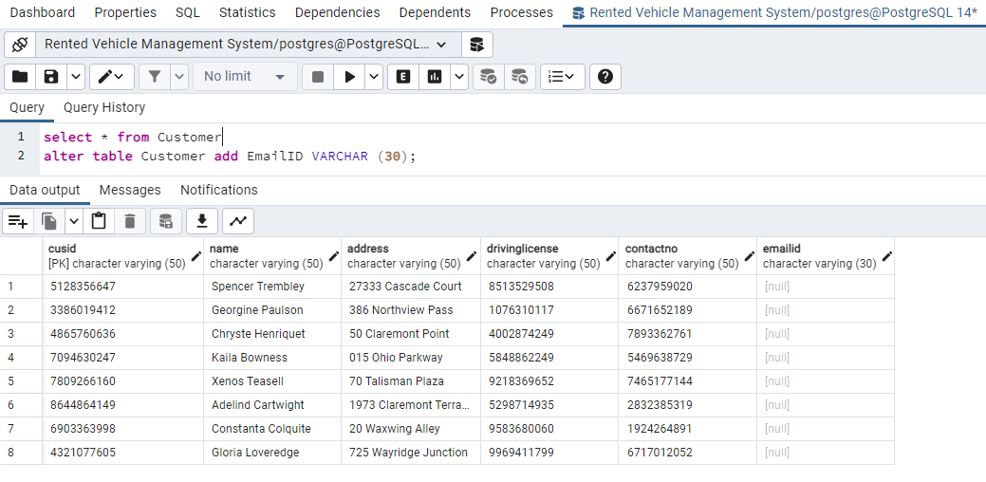

Original DB of Vehicle:

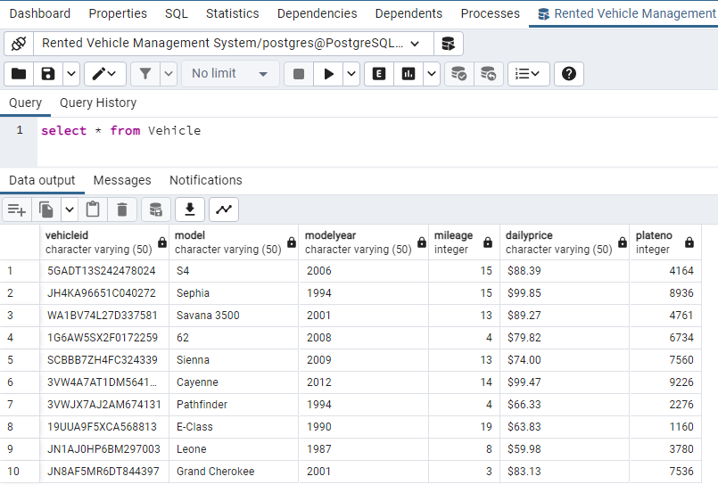

Altered a Primary key in the Table:

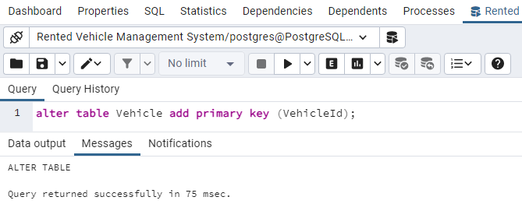

Altered table for Dropping a Column:

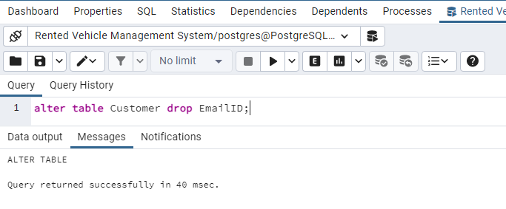

Table displaying the Dropped Column:

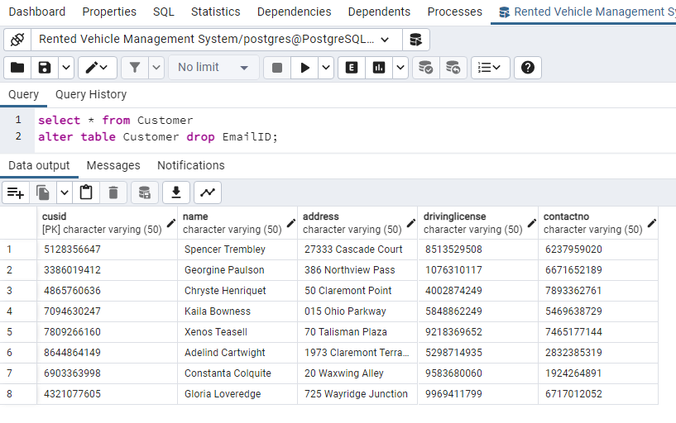

**2) Truncate**

Original DB of Vehicle:

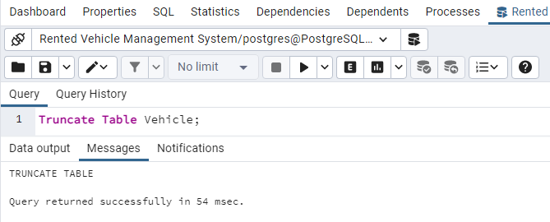

Truncated the table:



Output:

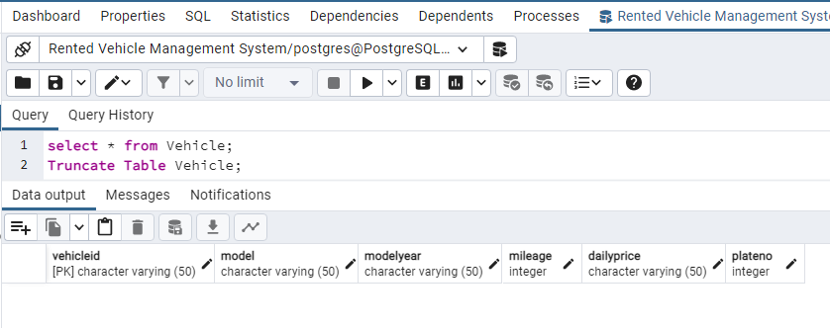

**3) Drop**

Original DB of Rent:

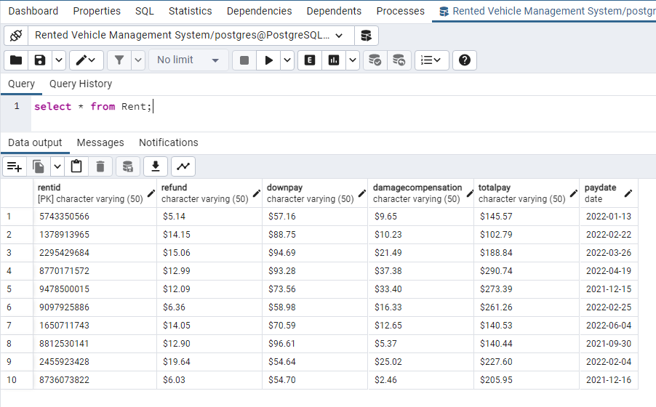

Dropped table:

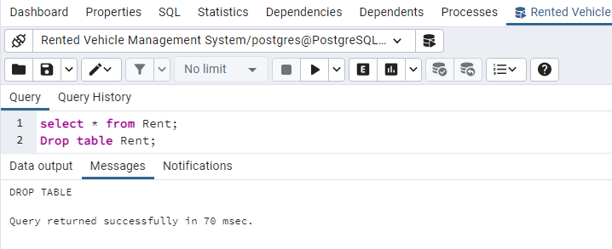

Output (Error showing table does not exist):

